*Saimon Ma*

*Eric Scherper*

*Tyler Burgett*

*Paulina Antillon*

*Austin Walther*

*Edits by Paulina, Austin and Eric, Diagrams by Tyler, cards by Saimon*

Trench Checkers Rulesheet

version 04

# Game overview

Trench checkers is a strategy battle game where the goal of the game is to obliterate the enemy army.

Number of Players: 2

Game Length: 15-30 minutes

# Contents:

* Game Board
* Soldier Pieces (12x per color)
* Commando Pieces (1x per color)
* Terrain Pieces (3x per color)
* 11 different Ability Cards (3x each)
* Dice(2x per color): d4, d6, d8, and d10

# Setting up:

Before the game starts, set up the board according to this diagram. Shuffle the deck of Ability Cards and distribute 6 cards to each player’s hand. This is the player’s secret arsenal and should be kept from the other player’s view.

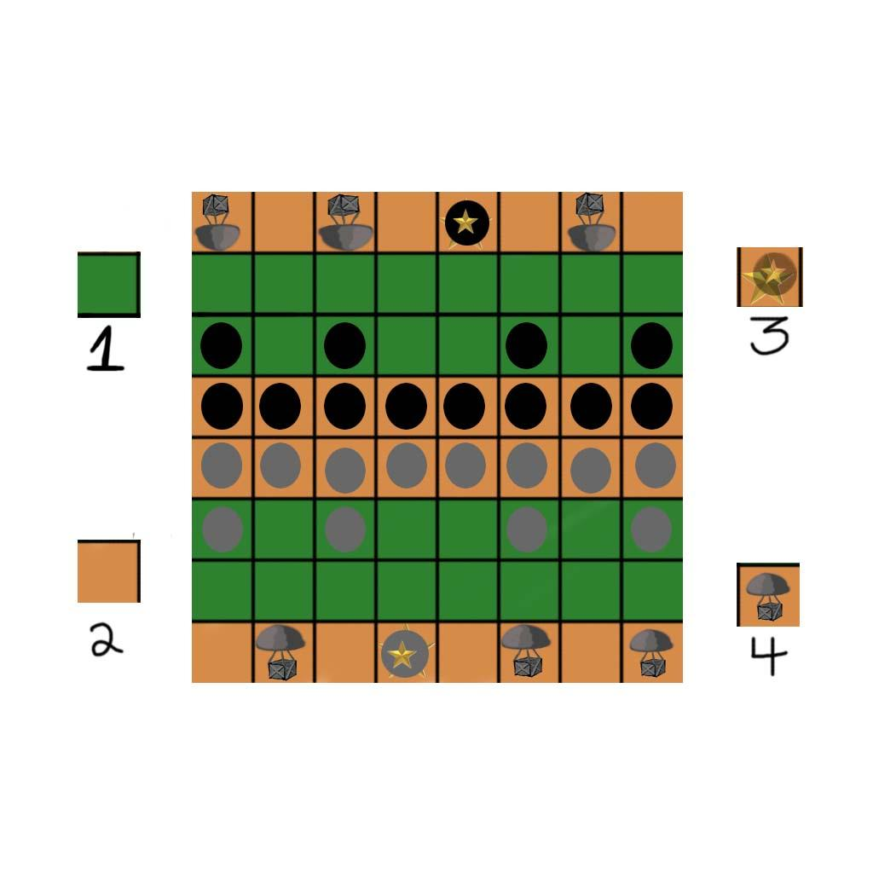

Tile Types:

* (1) Grass - Terrain can be placed anywhere on the grass tiles.
* (2) Trench - Terrain can’t be placed anywhere on the trench tiles
* (3) Commando - Placed on opposite sides of the board.
* (4) Supply Depot - Moving a friendly unit on or past the supply depots on the opposite side gives you one ability card each. Each Supply Depot can supply one ability card per game

# Starting the game:

* At the beginning of the game, whoever rolls a higher number from a d6 dice decides who gets to go first.
* The players take turns placing terrain anywhere in an unoccupied grass space of their board until there’s no more terrain pieces.
* When all terrain pieces have been placed, the player who rolled the higher number begins their movement phase.

# Movement Phase:

During their respective turn a player must make three moves in any type of combination they want.**During a player’s turn in the movement phase, a player may move any combination of pieces totaling up to three movements on the board**. Some example combinations of movements include:

* Move 1 piece three tiles,
* Move 1 piece 2 tiles and another piece 1 tile, or
* Move 3 separate pieces 1 tile each.

Rules for movement:

* Stacking or unstacking a piece counts as a move.
* Stacks may not move together except when one or more of the pieces is a Veteran or a Commando.
* Veterans can only stack with other Veterans or a Commando
* Pieces may not move diagonally.
* Pieces may not move through active enemy units or through terrain.
* If a player can move and has movements remaining, he has to move.

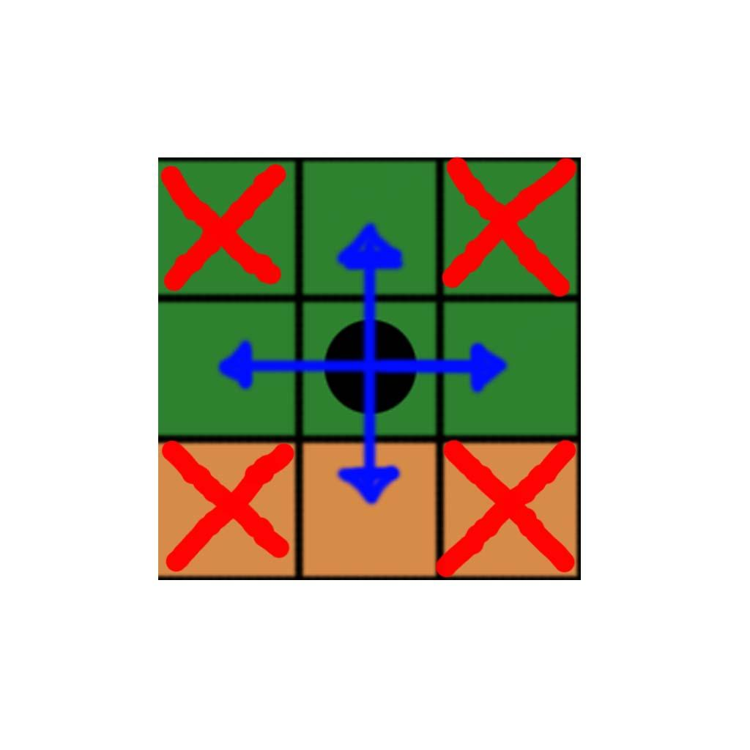

When a player has used up all of his movements, the other player moves his pieces and then the game shifts into Attack phase.

# Stacking:

Players may stack a unit up to 3 units in height. An unstacked unit rolls a d4 for attack and defense. Stacked units are stronger: a 2-unit stack rolls a d6, and a stack of 3 rolls a d8.

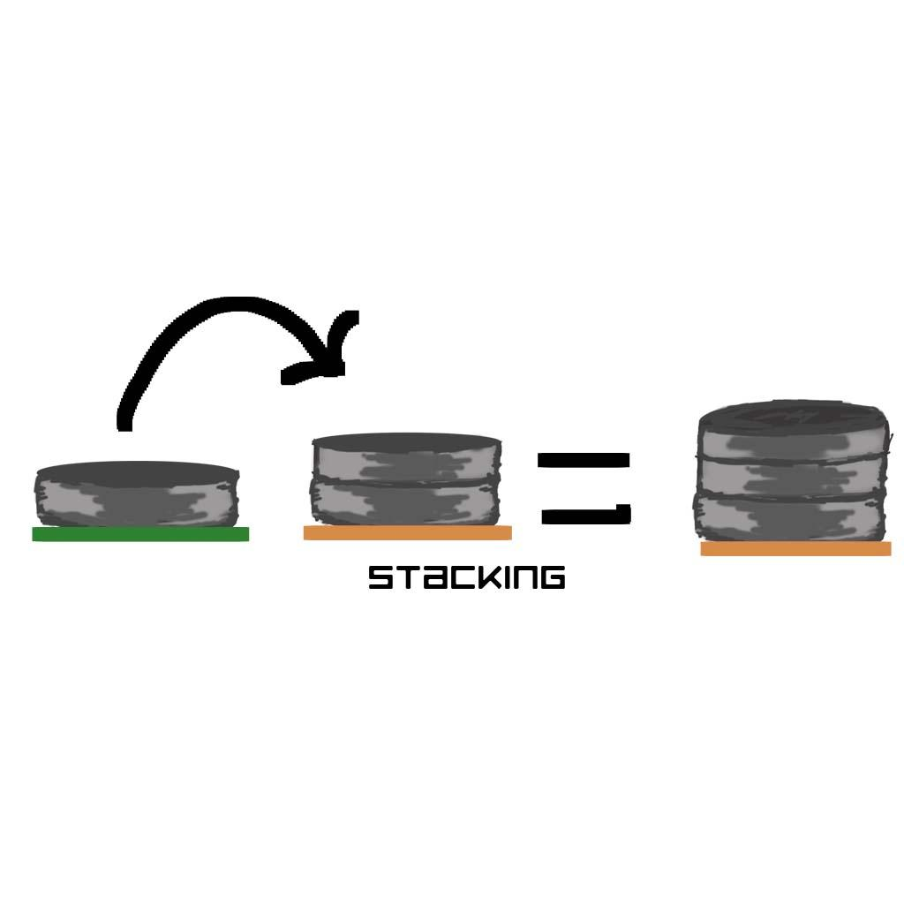

Attack Phase & Combat:

During the game’s attack phase, a player may choose to attack any enemy unit with one of his or her adjacent units. The player who went first during the movement phase goes first during the attack phase. Each player may attack once per attack phase. Attacking is optional.

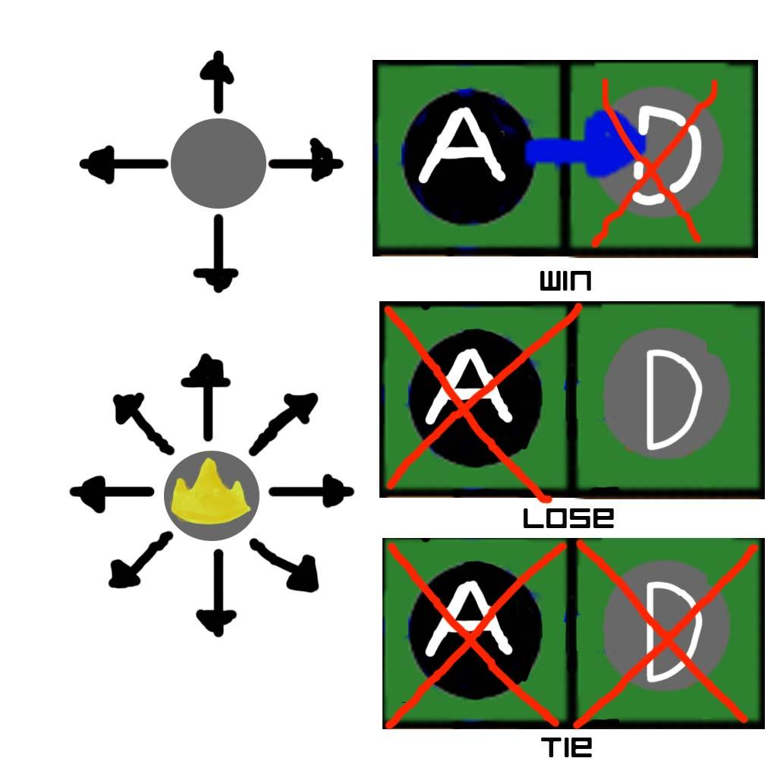

* During combat, both the attacking and defending player rolls a dice to determine who wins the battle. The type of dice is determined by the height of the stack: a single unit rolls a d4, a stack of 2 rolls a d6, and a stack of 3 rolls a d8.
* Whoever rolls the higher number wins the battle.
* If the attacking player wins, the player moves the attacking stack into the defeated defender’s tile.
* If the defender wins, the entire attacking stack is removed from the board.
* In the event of a tie, both players lose their soldiers and they are removed from the board.

After the attack phase, whoever lost more pieces at the end of the battles decides who goes first next turn.

If the outcome of the battle is even or there was no battle, whoever gets a higher roll out of a d6 decides. The game returns to movement phase and repeats until one or both players run out of soldiers.

# Units:

**Soldier:** Typical unit. Rolls a d4 for attack and defense unless stacked.

**Veteran:** If a Soldier is able to make it all the way to the farthest enemy trench, the piece flips over and the unit becomes a Veteran.

Veterans can attack diagonally and roll twice for the highest number.

Veterans can also move entire stacks, However they may only stack with other Veterans or Commandos. When attached to a stack, the entire stack rolls twice for the type of die associated with the stack.

**Commando:** Commandos are the elite units of the game and roll d10’s by default. At the beginning of the game, a player’s Commando is inactive in enemy territory. It becomes active when the player stacks a piece on it or moves adjacent to it.

* Commandos can move entire stacks.
* If a Soldier makes it to the other side of the board and stacks onto a Commando, it becomes a Veteran.
* Since Commandos are on supply depots by default, moving on or past the tile supplies the player with a card.
* If a Commando stack loses a battle, the stack is cleared except for the Commando. It will have to be defeated again before it is removed from the game.

# Special Cases:

**Last Stand:** If you roll the highest number possible by the unit, and the enemy is a bigger stack, it defeats your unit in battle, but one unit from the enemy stack is removed from the board.

**Trail of Vengeance:** If your Commando doesn’t become active before the rest of your soldiers die in battle, it becomes active as your last remaining soldier on the board. The game continues until it destroys the enemy team or dies trying.

# Winning :

A player wins the game when all of the opposing player’s pieces are removed from the board.

# Cards:

Ability cards mix up the gameplay of Trench Checkers. Players may choose whether to play with or without the cards. The name of the card, its’ ability, and when a player may use it is indicated on the card.

